ART-A000-MAES Nicolaes (1634-1693)-Rembrandt School-Portrait of a laughing boy with a wide-brimmed hat-Red Chalk on Light Brown Paper-c 1652-1653, Amsterdam

Title: Portrait of a laughing boy with a wide-brimmed hat Medium: Red chalk on light brown paper

Nicolaes Maes (1634-1693) became an apprentice to Rembrandt (1606-1669) in 1649 in Amsterdam. At this time Rembrandt engaged Hendrickje Stoffels as a servant of his household by whom he had a daughter, Cornelia. Rembrandt was in debt from the purchase of a large home with a studio in Amsterdam in 1639 (now the Museum het Rembrandthuis). His financial obligations on making this purchase were a major source of his financial difficulties in the 1650s. The apprenticeship of Maes and other students was needed to paint in background scenes and washes for paintings he needed to sell to offset his financial obligations since his drawings and paintings were turned over to his creditors via the courts from 1656 to 1658.

Maes initially painted genre scenes under Rembrandt’s guidance, using chiaroscuro and warm coloration. Then, under Rembrandt’s guidance as well, he began to draw portraits in red chalk which used the warm coloration of red chalk and smoother figural outlines than his master’s, but it was this approach that created its Maes’ demand as in the current red chalk drawing of “A laughing boy with a large hat.”

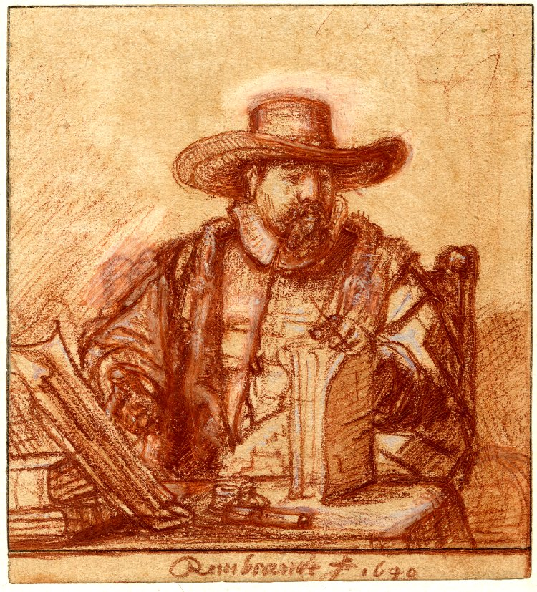

Rembrandt, “Portrait of Cornelis Claesz Anslo (1592-1646),” the cloth-merchant, theologian, Mennonite minister and preacher; seated at a table, wearing Mennonite ecclesiastical vestments, a wide-brimmed hat, with his left hand resting on a Bible (?) which stands upright on the table and with his right pointing to Martin Luther’s Sermons (?). Red chalk. 1640, British Museum. This was a study for an etching, which preserves the ruled framing lines in pen and black ink which were followed by the indented stylus outlines for transfer to a copper plate and the ochre wax medium on the verso that bled through to the recto.

In 1653, in the midst of Rembrandt’s financial and marital difficulties, Maes decided to move to Dordrecht (1653-1674), where he turned to the lucrative painting of Baroque State Portraits. In Dordrecht he amassed a substantial part of his estate of 11,000 guilders and became financially successful unlike his master. In 1674, five years after the death of Rembrandt, he felt it was safe to return to Amsterdam where he continued to earn a living by painting portraits with the masterly expertise he had learned from Rembrandt but with enough distance from him to maintain his own style.

Appendix: MAES Nicolaes (1634-1693)-Rembrandt School 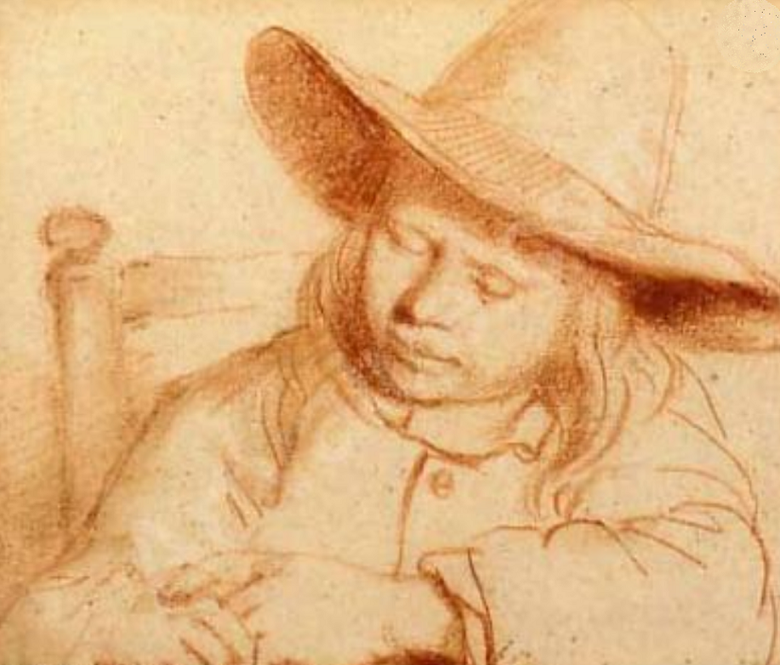

Portrait of a boy seated at a table sleeping, Christie's, New York, c 1652-1653. From Cat. No.: 1192, Old Master And 19th Century Drawings, New York, Wednesday, January 22, 2003. Lot 90. Estimate: 6 000 USD - 8 000 USD

Note the smooth outlines of the boy’s face and his distinctive wide-brimmed hat, two features that are prominent in the current portrait, “Portrait of a laughing boy with a wide-brimmed hat” and differ from Rembrandt in more angular facial lines and head gear.

**References:**

Otto Benesch, 'The Drawings of Rembrandt', Oxford 1973 (6 vols)

Robinson. William W. 1996. The early works of Nicolaes Maes, 1653 to 1661.   
Ph. D. Harvard University.